Workshop 3

ZHANG AO, WANG XINRUI, LI LIPING

Q1:

Overall, does the model look reasonable? Are the residuals OK? If you want to estimate a slightly different model, select **Estimate** from the menu bar of the current Equation window. Note that in EViews the differencing operator is D( ). For example, D(USD) is a new variable which equals the changes in USD. What can you conclude from the relation between the Euro, the SGD and the USD?

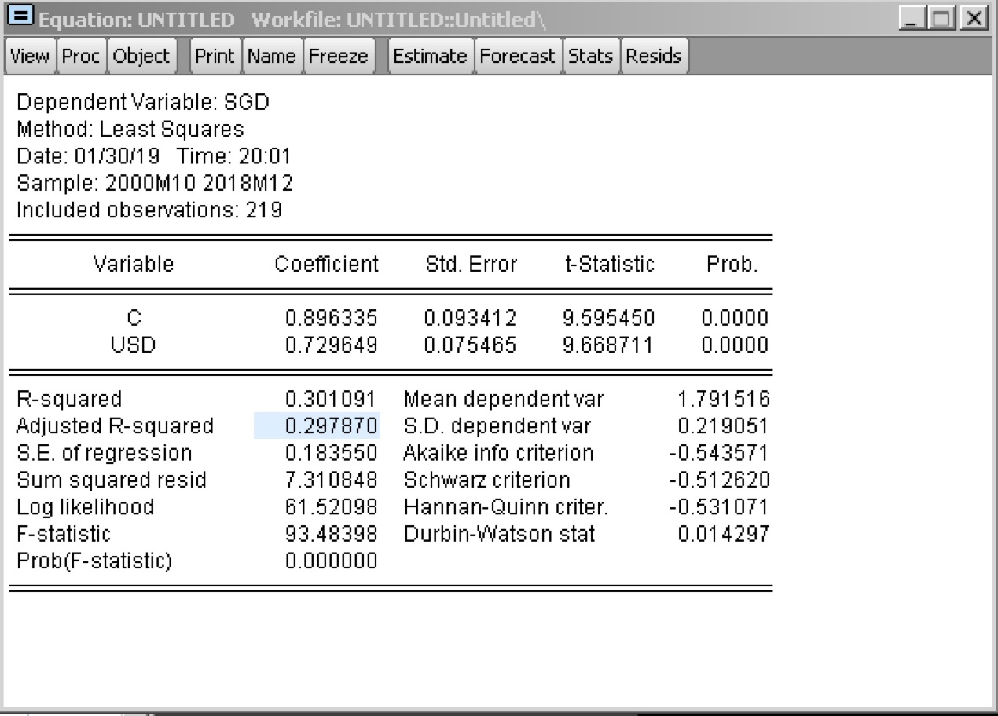

The coefficients of this model are all significant, and the r square is 0.301091. the model shows the coefficient and some statistics. from the coefficient, when there is an increase of one unit in the usd/euro, the sgd/euro exchange rate will increase 0.729649. as the p-value, it is statistically significant. the standard error is 0.183550, relatively a large percent. From the DW stat, we see there is autocorrelation in the model, and it is positive since it is lower than 2.

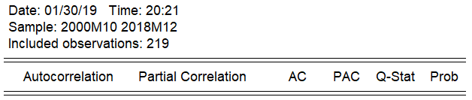

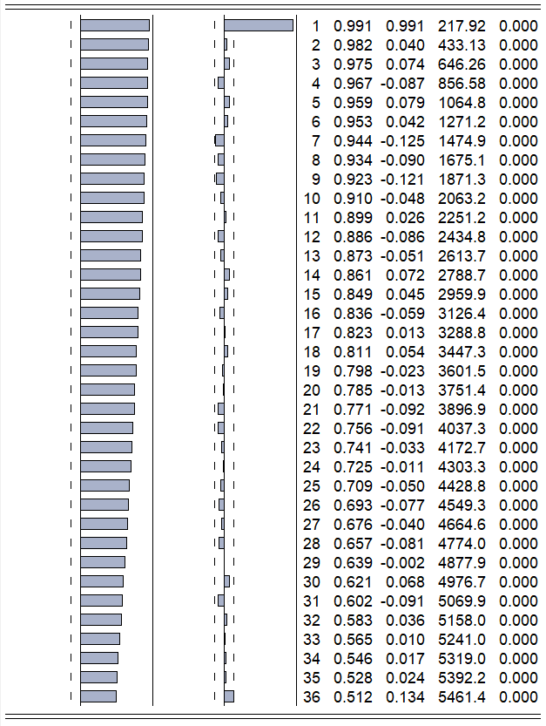

We draw a correlogram of residualas as shown below. Howerver, the correlation is not obvious. We also do some little improvement and D(sgd) and D(usd) are implemented into the model as variables. The relative correlation is more obvious, and this model is more reasonable.

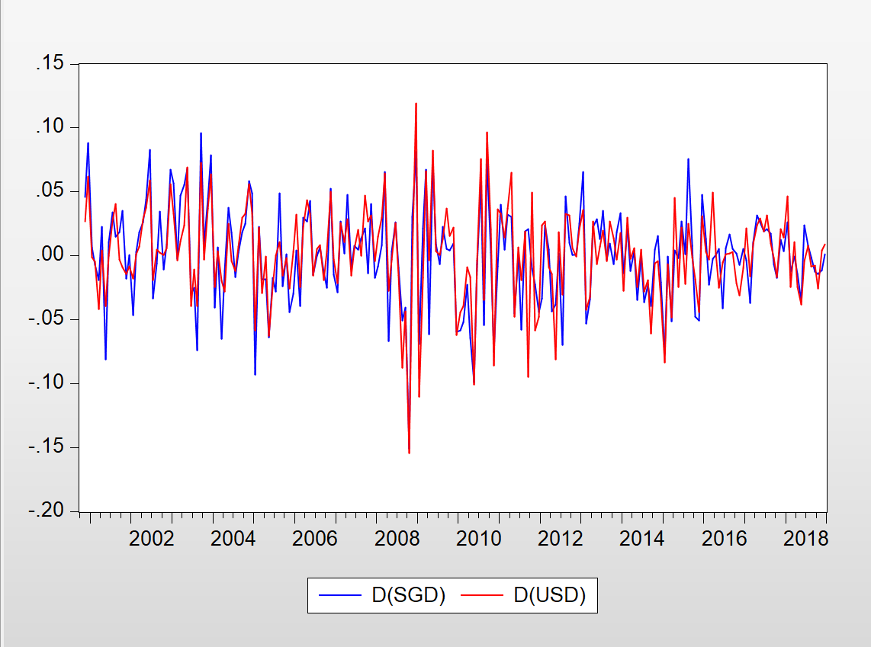

1. If Ms. Franklin had one thousand dollars to spend on either advertising or promotion, which should she choose, and why? What is the effect of one thousand dollars spent on each?

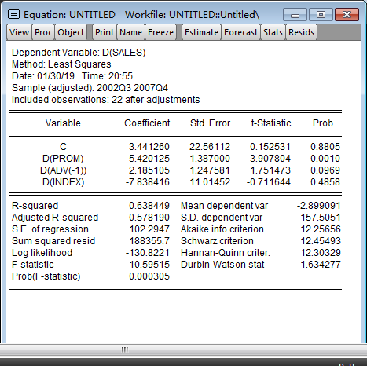

She Should choose promotion, the coefficient of promotion is significant and positive (5.42), so it has a positive effect on the sales. While the coefficient of adv is insignificant, so we don’t know the effect of adv on sales.

2. As described above, the economic analyst thought that the meat loaf mix was a “counter-cyclical” item. Would you agree?

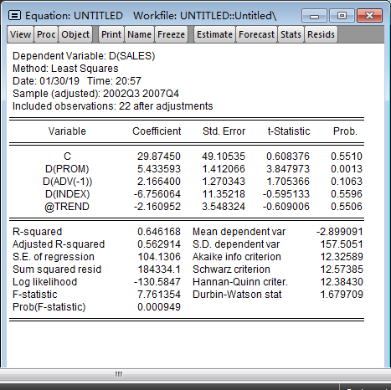

We don’t agree on that, we add trend in our model, but the significant is insignificant, so the sales don’t change with the trend.

3. As described above, the sales vice-president stated that company policy was that the company should advertise or promote in a given quarter, but not both. Has this policy been followed for meat loaf mix for the past 24 quarters?

By observing the data, the policy was not strictly followed, some quarters had expenditures on both promotion and advertisement.

4. Do you think there are significant seasonal effects associated with meat loaf mix sales? How do you know?

from the above result, the coefficient of index is not statistically significant, which means that the seasonal cycle does not affect the sales.

N.B. You may find the EViews lag operator useful (e.g. advert(-1)), and possibly also the difference operator (e.g. D(advert)).